**Q. Draw a hand-held magical heart which blinks 60 times a minute with red colour if held from one side and 120 times a minute with green colour if held from both the sides.**

**CIRCUIT DIAGRAM :**

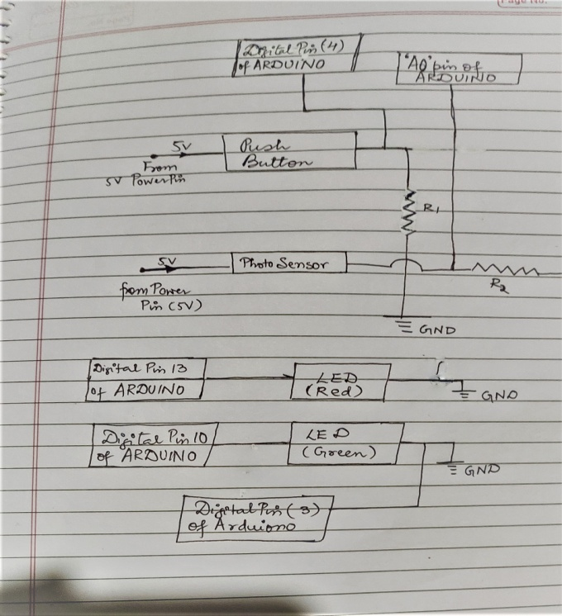

**THEORY :**

* **CONCEPT USED : According to the question, on one side(say left) I used a push button and on the other side(say right), I used a photo sensor.**

**When user will hold the heart from one end (say left), the push button which would be set in that manner that it gets pressed and red light will blink 60 times a minute by using delay(500); .**

**When user holds it from both sides i.e push button is pressed and along with it intensity of light to be sensed by the sensor decreases as hand will cover the sensor. So, using programming we will make the green led blink 120 times a minute using delay (250);. Both red and green LED’s are fit inside the heart.**

* **LEARNING AND OBSERVATIONS : We learnt to use different concepts to perform this task. We used a Push button and Photo sensor simultaneously. When user will hold the heart from one end (say left), the push button which would be set in that manner that it gets pressed and red light will blink 60 times a minute by using delay(500); .**

**When user holds it from both sides i.e push button is pressed and along with it intensity of light to be sensed by the sensor decreases as hand will cover the sensor. So, using programming we will make the green led blink 120 times a minute using delay (250);.**

* **PROBLEMS AND TROUBLESHOOTING: According to me there was no problem in establishing the circuit, but the major task was to write the code. I had to re-write code a number of times.**
* **PREACAUTIONS: We just have to make sure that the connectivity of hardware components and arduino along with code are correct.**
* **LEARNING OUTCOMES: I personally feel I learned a lot. I got to know my weak and strong points. This will surely stay with me forever. It makes you happy and your inner self gets satisfied. I got new ideas of writing codes and establishing hardware.**
* **CODE:**

int r1,r2;

int sV =0 ;

int sP = A0;

void setup(){

pinMode(4,INPUT);

pinMode(3,INPUT);

pinMode(10, OUTPUT);

Serial.begin(9600);

pinMode(13,OUTPUT);

}

void loop()

{

sV = analogRead(sP);

Serial.println(sV);

delay(100);

r1 = digitalRead(4);

r2 = digitalRead(3);

if (r1 == HIGH && sV <=300 ){

digitalWrite(13,LOW);

digitalWrite(10, HIGH);

delay(250);

digitalWrite(10, LOW);

delay(250);

}

else if (r1 == HIGH && r2 == LOW) {

digitalWrite(13,HIGH);

delay(500);

digitalWrite(13,LOW);

delay(500);

}

else {

digitalWrite(13,LOW);

digitalWrite(10, LOW);

}

}